GOVERNMENT ARTS AND SCIENCE COLLEGE, KANYAKUMARI- 629401

FACULTY PROFILE

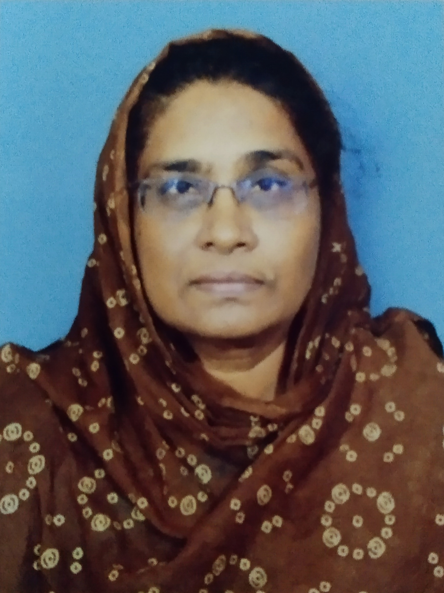

1) Name | : | Dr. M.I. MOHAMED UMMA
2) Present Designation | : | ASSISTANT PROFESSOR OF COMMERCE  GOVT ARTS & SCIENCE COLLEGE KANYAKUMARI
3) Date of Birth | : | 09-04-1964
4) Gender | : | Female
5) Community | : | BCM
6) Residential Address | : | ISHAAQ MANZIL,5/32 MUSLIM STREET,  PERUVILAI, NAGERCOIL – 3
7) Contact Nos. | : | 9787763695
8) E-mail id | : | mohamedumma@gmail.com
9) Date of appointment in the  present post | : | 30-01-2010

10) I. Particulars of Educational Qualification:

Name of the Degree | Specialization | Year of Passing | Name of the College | Name of the University | Division / Grade / Merit
B.Com | Commerce | 1984 | Holy Cross College, Nagercoil | Madurai Kamaraj | 1st class
M.Com | Commerce | 1987 | S.T.Hindu College, Nagercoil | Madurai Kamaraj | 1st class
M.Phil | Commerce | 1992 | - | M.S. University | 1st class
Ph.D. | Commerce | 2015 | - | M.S. University | -

11) Total teaching Experience
Name of the College | Whether Govt/Aided/S.F | Designation | Joining Date | Relieving Date | Experience
 |  |  |  |  | Years | Months | Days
MUSLIM ARTS COLLEGE, THIRUVITHANCODE | SF | LECTURER | 19-08-1987 | 29-01-2010 | 22 | 5 | 10
GOVERNMENT ATRS COLLEGE FOR WOMEN, RAMANATHAPURAM | GOVERNMENT | ASSISTANT PROFESSOR | 30-01-2010 | 07-08-2013 | 3 | 6 | 8
GOVERNMENT ARTS AND SCIENCE COLLEGE, KOVILPATTI | GOVERNMENT | ASSISTANT PROFESSOR | 08-08-2013 | 21-04-2022 | 8 | 8 | 15
GOVERNMENT ARTS AND SCIENCE COLLEGE FOR WOMEN, ALANGULAM | GOVERNMENT | ASSISTANT PROFESSOR (DEPUTATION) | 22-04-2022 | 08-08-2022 | --- | 3 | 17
GOVERNMENT ARTS AND SCIENCE COLLEGE, KOVILPATTI | GOVERNMENT | ASSISTANT PROFESSOR | 09-08-2022 | 10-08-2022 | -- | --- | 2
GOVERNMENT ARTS AND SCIENCE COLLEGE, MANUR | GOVERNMENT | ASSISTANT PROFESSOR  (DEPUTATION) | 11-08-2022 | 05-01-2023 |  | 4 | 25
GOVERNMENT ARTS AND SCIENCE COLLEGE, KANYAKUMARI | GOVERNMENT | ASSISTANT PROFESSOR  (DEPUTATION) | 06-01-2023 | TILL DATE |  | 3
Total |  |  |  |  | 35 | 7 | 17

12) Research Experience :
- Research guidance :
S.No | Name of the degree | No.of students degree awarded | No.of students guiding at present
1 | M.Phil | Nil | Nil
2 | Ph.D | Nil | Nil

b) Details of Ph.D Programme guided:
Name of the scholar | Title | Submitted | Awarded | Name of the University | Month & year
Nil | Nil | NIl | Nil
c) Research Project:
S.NO | NAME OF THE ASST./ ASSO.PROF., | NAME OF THE MAJOR /MINOR PROJECT | SUBJECT RELATED TO | AMOUNT SANCTIONED/ YEAR | AMOUNT RELATED | NAME OF THE FUNDING AGENCY (UGC/MHRD/ DST/ Etc..)
NIL

d) Research Publication:
S.No | Name of the Research Publication | Journal | Month & Year
1. | Progressive Trend on Indian Tourism Industry | RAC Journal of Research | 2(7)(5-9)2013
2. | A Study on customer attitude towards internet banking services in kanniyakumari district | International journal of multi-disciplinary research studies | Mar,2021
3. | A study on problems of entrepreneurs in kanniyakumari district | International journal of multi-disciplinary research studies | Dec,2021
4. | A Study on satisfaction of Investors towards investment in Kovilpatti of Thoothukudi district | International Journal of Humanities law and social studies | Nov,2022

13) Orientation / Refresher

Name of the Programme | University | Duration
Orientation | Madras University | 4.5.2011 to 2.6.2011
Refresher | Kerala University | 19-06-2013 to 09-07-2013
Refresher | Madural Kamaraj University | 16-11-2018 to 06-12-2018
Refresher | Madural Kamaraj University | 21-01-2020 to 03-02-2020
Refresher | Ramanujan college New Delhi | 25.01.2021 to 08.07.2021

14) Training:

Name of the Programme | University | Duration
Orientation | Sri Avinashilingam Education Trust. Institutions Training and Orientation Centre, Coimbatore, N.S.S. H.R.D. Govt of India | 17-07-1992 to  29-07-1992
Special Course on student counseling | M.S. Universtiy | 1992-93
Training programme on Consumer Protection | Pioneer Kumarasamy College, Nagercoil | 15-02-1994
jkpof fpukhq;fSf;F Efh;Nthh; ghJfhg;G gw;wpa gapw;rp | Kodaikanal | 07-07-1994 to 09-07-1994
Film Appreciation Course | M.S. University | 25-04-1994 to 27-04-1994
AIDS Awareness Training Programme | M.S. University | 23-08-94 to 26-08-1994
Train the Trainer Program | Infosys Technologies Chennai | 20-09-2011 to 30-09-2011
Faculty Development Programme | M.S. University | 24-02-2017 to 03-03-2017
Faculty Development Programme | Bharathiar University, Department of Phisycal Education, Under RUSA II (BEICH), Coimbatore | 08-07-2020 to 14-07-2020

15) Seminar, Conference, Symposia, Workshop etc attended:
S.No | College/ University | Topic | Date | National/ International
1. | Scott Christian College, Nagercoil | Financial Services | 12-10-2004 | National
2. | Noorul Islam College, Kumaracoil. | Marketing Innovations and Communication Strategies | 23-03-2006 | State.
3. | Womens Christian College, Nagercoil | Net Banking and Net work Security | 04-10-2006 | State
4. | Scott Christian College, Nagercoil | Human rights and Strategies | 26-03-2007 | State
5. | Alagappa University, Karaikudi | Symposium on women in Administration Trends, Challenges and opportunities | 08-03-2012
6. | M.S. University, Tirunelveli | Corporate Governance and Corporate Social Responsibility | 18-03-2016 | Regional
7. | M.S. University, Tirunelveli | Companies act 2013 Structural Reformation you need to know. | 03-08-2018 | National
8. | Womens Christian college, Nagercoil | Emerging trends in financial market | 05-03-2019 | National
9. | Dr. Zakir Husain College, ILayangudi | Modern Teaching Techniques | 17-05-2020 | Webinar
10. | Sri. Meenakshi Government Atrs College For Women, Madurai | Outcome Based Curriculum and Evaluation | 21-05-2020 | Webinar
11. | Thiagarajar College, Madurai | Economic Impact of Global Pandemic(Covid-19) | 08-06-2020 | International Webinar
12. | ST. Xavier’s College, PalaiyamKottai | Data Analytics | 22.-06-2020 | International Webinar
13. | ST. Xavier’s College, PalaiyamKottai | Emotional Well Being and Managing Stress | 24-06-2020 | International Webinar
14. | ST. Xavier’s College, PalaiyamKottai | Opportunites In New Normal | 25-06-2020 | International Webinar
15. | ST. Xavier’s College, PalaiyamKottai | Digital Accessibility Tech For Blind | 26-06-2020 | International Webinar
16. | ST. Xavier’s College, PalaiyamKottai | Data Visualization Using Tableau | 27-06-2020 | International Webinar
17. | ST. Xavier’s College, PalaiyamKottai | Mobile App Development Using IONIC Frame Work | 28-06-2020 | International Webinar
18. | M.K. University, Women’s Studies Centre | Crime against Women: Women’s Rights and Protection | 04-07-2020 | National webinar

16) Position held/ Role in organizations like NSS, NCC, YRC : NIL

17) Participation in Corporate life :
Contribution to
A) College:
- Hostel
- Sports - in - charge:
- Admission committee members:
- Placement cell:
- Anti-ragging: Member : yes
f) Women’s empowerment:

B) Membership/Participation in bodies/Committee on Education & National Development.
- Member of Senate :NIL
- Member, Board of studies : NIL

C) Served as Resource person in National / International Conferences, Academic staff college.
NIL
D) Any other information.
Head of the Department – Commerce.
Campus Cleaning Fund in-charge.(26/07/2012)Sports incharge
Disciplinary Committee member.
Librarian in-charge.
Additional examiner M.S university UG commerce major (09/12/14)
Additional examiner M.S university UG commerce major (April 15)
Chief superintendent M.S. university exam April-2018.GASC, Kovilpatti
OSA committee member ( GASC kovilpatti)
Additional Examiner, M.S. University B Com Revaluation- 12-02-2019.
External Examiner G.V.N College, Kovilpatti – B.com Field Work 09-04-2019.
Additional Examiner M.S. University ( Muslim Arts college, Thiruvithancode) – B Com Board -01-06-2019 to 07-06-2019.
Additional Examiner, M.S. University (Women’s Christian College,Nagercoil) – B. Com Major- 04-12-2019 to 12-12-2019
Chief Examiner M.S. University Examination Commerce Board. Nov 18
Chairman M. S. University Examination, April 2020 - Commerce Board.
Chairman M.S.University Examination Nov 2020-2021 – Commerce Board.
External Examiner Mini project B.com Degree Muthukaruppan Memorial Arts and Science college on 04.01.2022

.

